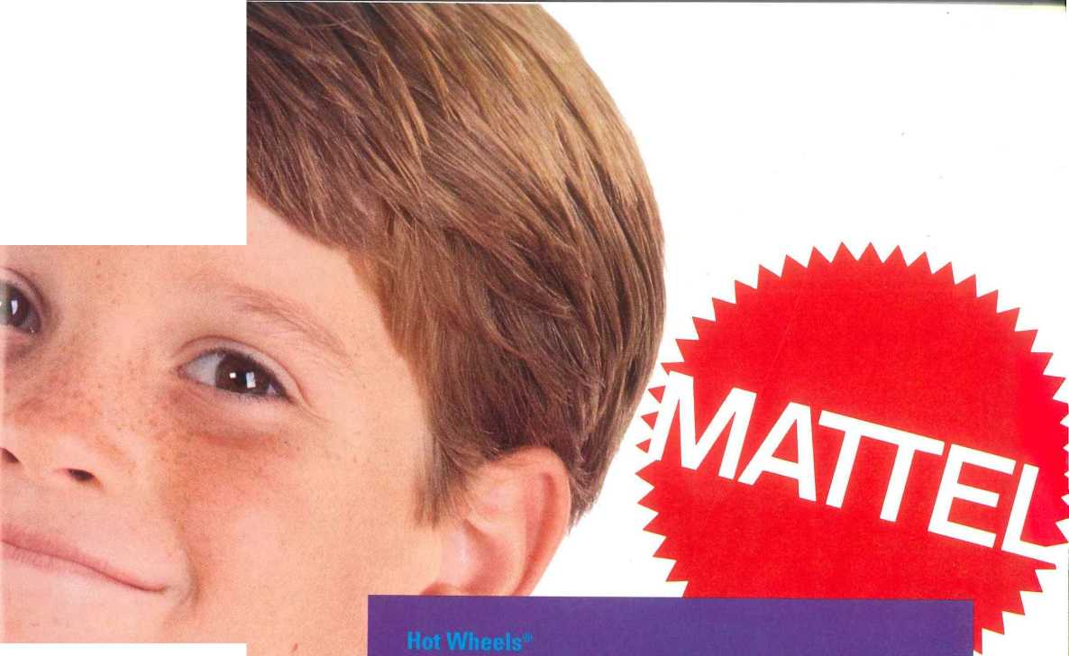

**Cars**

**Track System**

**Hot Wheels Adventures™**

**Road Wars™**

**Hot Wheels Top Speed™ -**

**Color FX™**

**Micro Hot Wheels**

**Space Patrol**

**Auto City**

**ckelodeon™**

—

**reet Sharks™**

**AAAHHM Real Monsters™**

**Judge Dredd™**

—

**Disney**

**Infant/Preschool**

**Pocahontas**

**See 'N Say®**

**Pooh**

The advertising, as shown, for spécifie products in this catalog, represents current planning. While the intention is to deliver such advertising, plans may change our discrétion.

We hâve tried to make the information in this catalog as complété and accurate as possible. However, Mattel Toys reserves the right to make changes, without notice or obligation, in coiors and materials and to change or discontinue items in our line. Thank you for your understanding and support.

©1995 Mattel, Inc.

El Segundo, CA 90245, USA. Ail Rights Reserved.

Catalog no 13952.